St Joseph’s School Uniform
Our school uniform consists of the following:
Boys
Grey jumper
Grey shorts
White shirt
School tie
Black shoes (no trainers or canvas shoes)
Grey Socks

Girls
Grey jumper or cardigan
Grey skirt or pinafore
White blouse
School tie
Black shoes (no trainers, canvas shoes, boots or highly decorated shoes)
Grey socks
In summer, girls can wear a summer dress (pale blue and white gingham check),
a grey cardigan (no sweatshirts), white socks and black shoes.

School Uniform can be ordered from

Ties can be bought through the school office.

P.E. KIT
Indoor Kit
Black or navy shorts or PE skirt (no logos)
Plain white t-shirt (no logos) or school polo shirt
Pumps (not trainers)
Outdoor Kit
Training shoes
T-shirt as above
School sweatshirt
Shorts

Swimming Kit
Girls- one piece costume (no bikinis)
Long hair must be tied back or put into a swimming cap.
Boys- Swimming trunks (no shorts)
Swimming cap

No child is allowed to undertake any P.E. activities while wearing earrings, watches or jewellery of any kind. Children should either remove such jewellery themselves or
come to school with plasters over their studs. All jewellery must be removed for swimming.

Nail varnish, temporary tattoos and make up of any kind are not allowed.

Wearing a uniform is a badge of pride, creates an identity for a school and is an important part of being a pupil. Uniforms show that you are part of an organisation. Wearing it says we're all in this together. Also, if you wear your uniform with pride, it means you are half way there to being respectful, buying into what St Joseph’s is all about.
Uniforms give students a sense of belonging to a particular school and create an identity for the school in the community. A school uniform teaches students to dress smartly and take pride in their appearance. A school uniform can improve learning by reducing distraction, sharpening focus on school work and making the classroom a more serious environment, allowing students to perform better academically.
The following shoes are suitable for our school uniform:

Girls
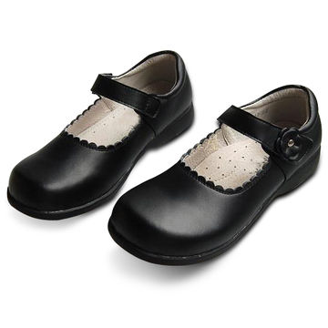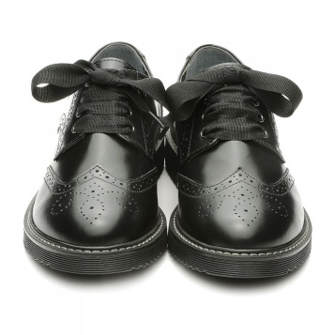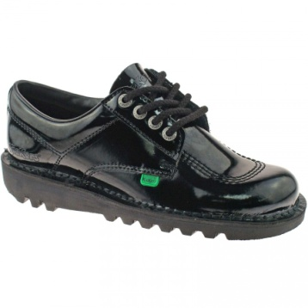
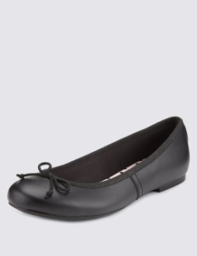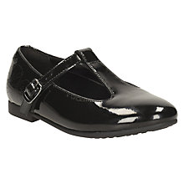

Boys

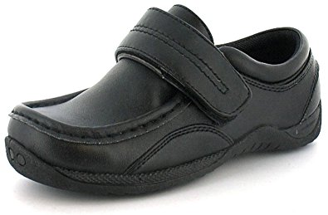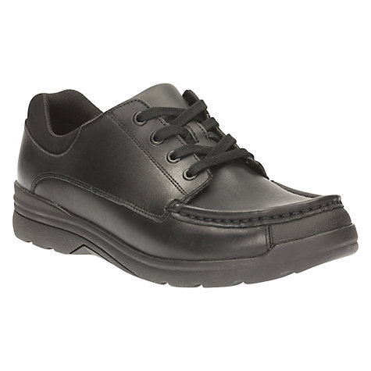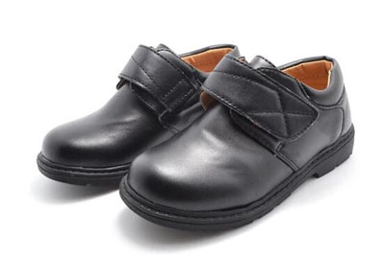

The following shoes are not suitable for boys or girls:
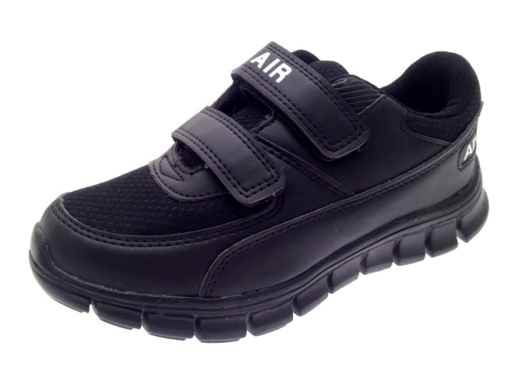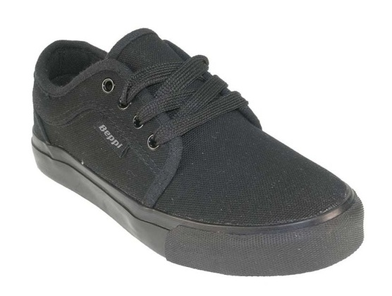

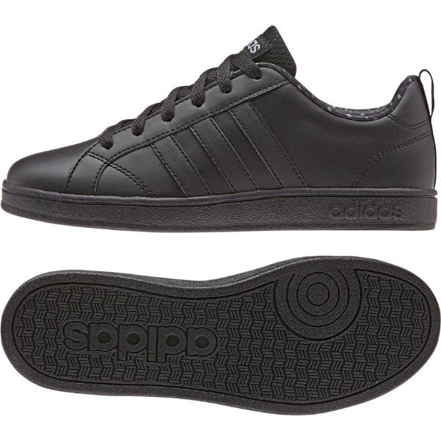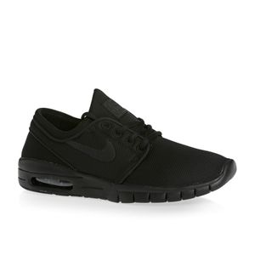

If parents are unsure whether a shoe is suitable for school or not, it probably isn’t.

