NPS are as dangerous as illegal drugs

‘NPS’ are designed to mimic the effects of illegal drugs so often they pose the same risks to the users. Over the past few years there has been an increasing trend in deaths from ‘NPS’. Vertex (pictured right) has recently been responsible for several hospitalisations in Merseyside and has been linked to deaths in Japan and Germany.

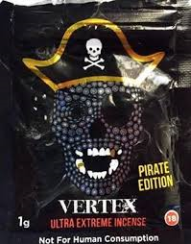

NPS are a growing problem

They are often designed to mimic the effects of illegal drugs. For example ‘gogaine’ is designed to mimic the effects of cocaine. These are often cheaper and can be bought in shops (called ‘head shops’) in Liverpool City Centre without any knowledge of what a ‘safe dose’ would be. More than 450 different ‘NPS’ are known about, over 100 of these catalogued within the last year alone.

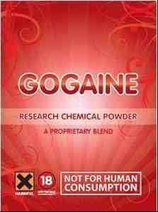

Nitrous oxide is the second most used drug by young people in England

Use of nitrous oxide (Balloons or laughing gas) has risen in popularity over the last few years. Usually signs of nitrous oxide use are easy to detect, with balloons and cream chargers (pictured right) left around in fields and streets. Young people we work with are reporting using BBM (Blackberry messaging service) to have nitrous oxide home delivered!

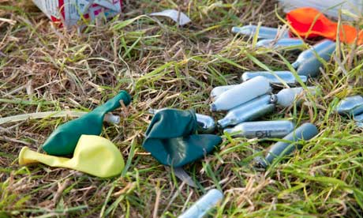

‘Legal high’ use can be difficult to detect

Some so called ‘NPS’ are easy to detect like nitrous oxide, but take the new C-liquids that can be smoked in an e-cigarette with no obvious smell. These are based on herbal incense such as ‘spice’ or ‘sweat leaf’ (pictured right).
You would need to rely on your observational skills to detect signs of intoxication in your students.

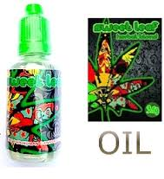

Support is available for young people in Knowsley using ‘NPS’

Knowsley Youth Mutual (KYM) can offer support to your school around increasing basic awareness in young people and offering harm reduction advice. If you feel a young person needs more intensive support around their drug use, they can be referred into Engage Knowsley, the specialist drug and alcohol service. We are an outreach based service- so we support young people in schools, colleges, youth clubs and health centres.

